Mobile Marketing for Events & Venues
Open the Mobile Channel for Your Fans & Guests…TODAY!

For events, venues, fan engagement at arenas: You can create your own mobile marketing campaigns with _____’s self-service mobile platform.

Develop your own consumer lists, develop and launch in-venue promotions, coupons, sales alerts and surveys & research! Our self-service platform is easy to use and you can launch your mobile program in minutes.

Use our self-service platform to develop and launch your mobile campaigns. Recruit your guests, fans, and customers to opt-in and begin delivering sales-driving promotions and loyalty programs.

Mobile Services for Venues…On Demand!
You can send the alerts, promotions and consumer communication programs you want, when you need them. ______’s platform is an “on demand” tool – use it according to your business needs, not according to media schedules or printing slots. And it’s designed to work on ANY cell phone.

Our features and services include:

- Keywords for Recruitment
- Mobile Promotion & Couponing
- Mobile Web Pages
- Mobile Polling
- Mobile Info Requests
- QR Code generator
- Sales Alerts & Messaging
- Full Reporting

Additionally, ______’s fully synchronized client-server platform enables venue operators to adjust programs in “real time.” This allows you to change offers, modify messages or respond to information from your guests as you receive it. It’s an unprecedented opportunity to add value to guest experiences.

Give us a call today find how you can use _____’s services at your venue.

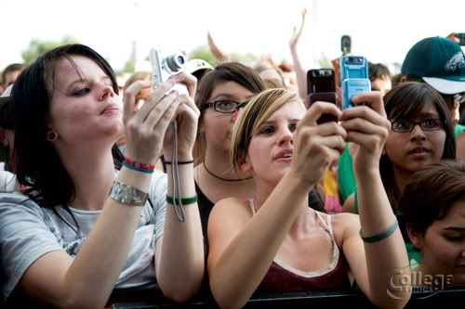

PLACE PHOTO HERE,
OTHERWISE DELETE BOX

BUSINESS NAME

Keyword – NAME

Offer:
FREE This with purchase of that. Limit
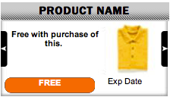

Fans everywhere use their mobile phones and text messaging to stay in touch, send news about shows, take advantage of offers & promotions, and more. Venue and event managers are using mobile to dramatically increase fan and guest engagement. Let ____ show you how!
_____________: For Events & Venues
Mobile Marketing For Venues, Guest Facilities, Arenas, Trade Shows…THAT WORKS!

Large venues catering to many guests and fans can use mobile marketing tools to greatly enhance and improve their guests’ experiences. Increasingly, in-event messaging is becoming a an integral part of guest and fan experiences at numerous types of venues, including sporting arenas, large restaurants, trade shows, concerts, and many more. Museums have even started using mobile services, to add information and valuable input about exhibits and to therefore enhance guest experiences.

Here are a few of the many ways in which venues are using mobile services:

- Find information about the facility’s amenities: ticket booths, water services, etc.
- Hear about and buy tickets for upcoming events
- Learn about and participate in today’s or this week’s special promotions being run by vendors on-site shops and stores
- Participate in live surveys and polls
- Learn more information about shows, events, etc
- Using opt-in capabilities to market future events
- And numerous others…

From racing and sports stadiums, to museums & theaters, to trade shows, to hotels and convention sites…mobile marketing services can offer valuable services to your guests and patrons.

Contact Us Today.
We can help get your venue and team set up. Give us a call at the numbers indicated below and get started.

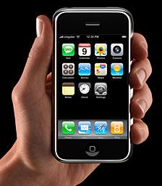

PLACE PHOTO HERE,
OTHERWISE DELETE BOX

Any phone works with ____ -- you can reach out to ALL your guests and patrons.
Open the Mobile Channel With _______ Today

Call: 999-999-9999

sales@yoursite.com
www.sitename.com

Text "KEY" to 71441 for sales info.

