

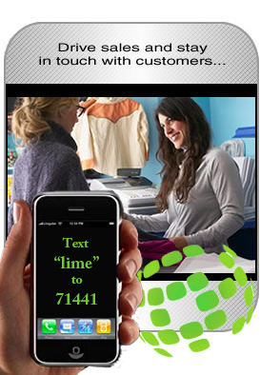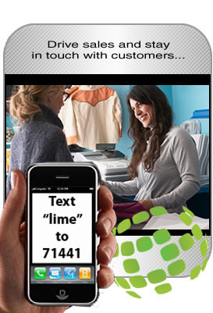

PLACE PHOTO HERE,
OTHERWISE DELETE BOX

“We’re able to move end-
of-day inventory and reward loyal customers – at the same time.”
Mobile Marketing for Local Businesses…
ON DEMAND!
Our platform was developed for the small and medium business market. ______ empowers the small and medium business community by bringing the power and sales-driving capabilities of mobile marketing to you cost-effectively and reliably – services usually reserved for only large organizations with big marketing budgets. Get started today!

Now you can send the promotions and consumer communications programs you want, when you need them. Lime’s platform is an “on demand” tool – use it according to your business needs, not according to media schedules or printing slots. And it’s designed to work on ANY cell phone.

_____ puts you in charge of your customer relationships. You can manage your store loyalty programs, increase sales driving promotions, reward frequent customers.

Open the mobile channel – with __________!
999-999-9999

www.site.com

sales@site.com

Contact ________ Today
_____________
Open the mobile channel!

We specialize in mobile marketing for small & medium business!

TBGFAC – Dunkin’ Donuts, Regional Manager
Your slogan here!
Copyright 2011 ______. All Rights Reserved.
_____’s clients and licensee users include:

your client/logo here
your client/logo here
your client/logo here

…and others, too.

Text “KEYWORD” to 71441

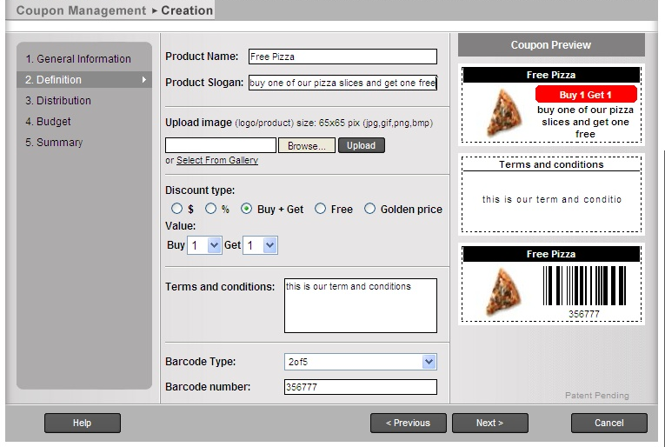
Mobile Marketing For Local Businesses…

THAT WORKS!

Easy to start. Easy to manage…

For small & medium businesses: retailers, restaurants, associations and more. You can create your own mobile marketing campaigns with ____’s self-service mobile platform.

Develop your own consumer lists, develop and launch targeted promotions, coupons, sales alerts and customer surveys & research! Our self-service platform is easy to use and you can launch your mobile program in minutes.

Use our self-service platform to develop and launch your mobile campaigns. Recruit your customers to opt-in and begin delivering sales-driving promotions and store loyalty programs. You can stay in touch with your customers and drive increased traffic and sales by using _____.

• Send sales alerts.
• Deliver promotions & coupons
• Launch customer surveys
• Track your results.

With ______, you can…

- Open Your ____ Account & Create Offers & Promotions

Log into our easy-to-use dashboard and
program launching platform and
you’re ready to go.

- Recruit Consumers to Sign Up

Use in-store signage or install ____’s recruitment widget on your website.

- Send Your Customers Alerts Promotions, Surveys and More

You can launch your programs
immediately, or schedule them
in advance.

- See Your Results Immediately

_____’s platform operates in
“real time” – see your results
as they happen –
refine your programs “on the fly.”

______’s Pricing Plan is geared to the needs of local businesses. Simple, easy and cost-effective.
Sign up today!

It’s FREE. Use _____ for the first 30 days at no charge.

Contact Us Today:
sales@site.com
999-999-9999
www.site.com

Pricing starts as low as
$29.95 a month

- Full system access
- 1 unique keyword
- 250 messages/month

More than 250 messages per month? Pay only for what you use. _____ offers a very competitive rate plan to keep your costs low and your customers coming back. See our website for more.

