


Mobile Marketing For Local Businesses
For small & medium businesses: retailers,restaurants, associations and more. You can create your own mobile marketing campaigns with _’s self-service mobile platform.
Develop your own customer lists, develop and launch targeted promotions, coupons, sales alerts, customer surveys & research! Our self-service platform is easy to use and you can launch your mobile program in.
Our platform was developed for the small and medium business market. ______ empowers the small and medium business community by bringing the power and sales-driving capabilities of mobile marketing to you cost-effectively and reliably – services usually reserved for only large organizations with big marketing budgets. Get started today!

Company puts you in charge of your customer relationships. You can manage your store loyalty programs, increase sales driving promotions, reward frequent customers.

,
Lorem Ipsum Dolor
Lorem
Ipsum Dolor
Integer egestas orci quis lorem feugiat adipiscing.

Easy To Start. Easy To Manage…

Drive Sales On Demand!
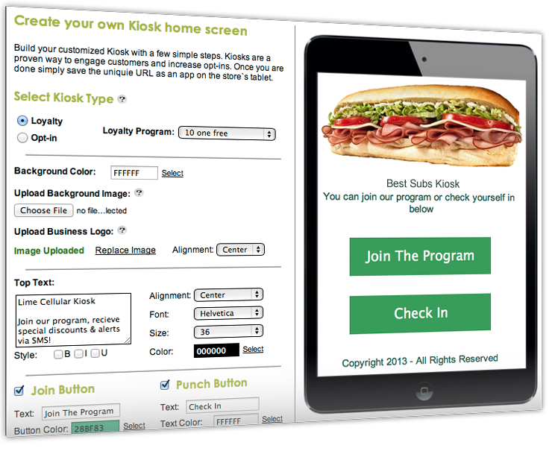
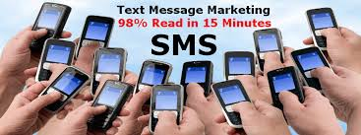
You Can Run Your Own Campaigns Or We Can Do It For You!
We offer a full-service Mobile Marketing Platform designed to meet your needs to engage customers and get them to repeatedly use your services, attend your events, come to your restaurant during slow times, etc.!
You can also leave all the marketing to us. We will take care of implementing and managing your messaging campaigns, your only duty is to take care of the increase in business coming your way!..

_____’s platform delivers these features, and more…

- Loyalty Kiosk
- Mobile Couponing
- Mobile Surveys & Research
- Social Media Integration
- Mobile Appointment & Confirmation
- Mobile Sales Alerts & Messaging
- Learn more information about shows, events, etc
- Multiple Keywords
- Complete Reporting

“Put a customer’s quote or company motto here.”
- Donec vehicula mauris in est

Loyalty Kiosk.
Company introduces an innovative Loyalty Kiosk.
Tool creates a web based Kiosk for tablets and works with both Android and Apple IOS.
This is the perfect tool to engage with customers at the point of sale, while waiting to be seated at a restaurant, text to win campaigns, bars/nightclubs, ect.

Loyalty Programs have been proven to increase opt-in rates by up to 5x!

