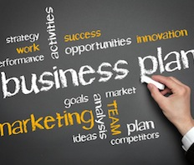
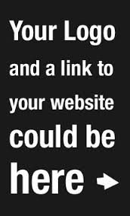

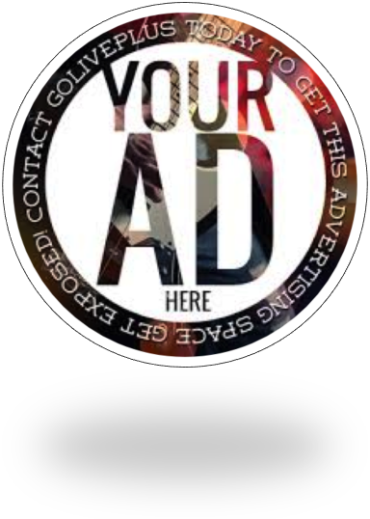

Drive Sales On Demand With Mobile Marketing!
Now you can send the promotions and consumer communications programs you want, when you need them. Company’s platform is an “on demand” tool – use it according to your business needs, not according to media schedules or printing slots. And it’s designed to work on ANY cell phone or tablet.

Easy To Start. Easy To Manage.
Our platform was developed for the small and medium business market. ______ empowers the your business by bringing the power and sales-driving capabilities of mobile marketing to you cost-effectively and reliably – services usually reserved for only large organizations with big marketing budgets. Get started today!
.
Lorem Ipsum
Lorem Ipsum Dolor Sit Amet.
Lorem Ipsum
,

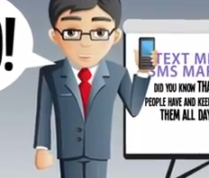
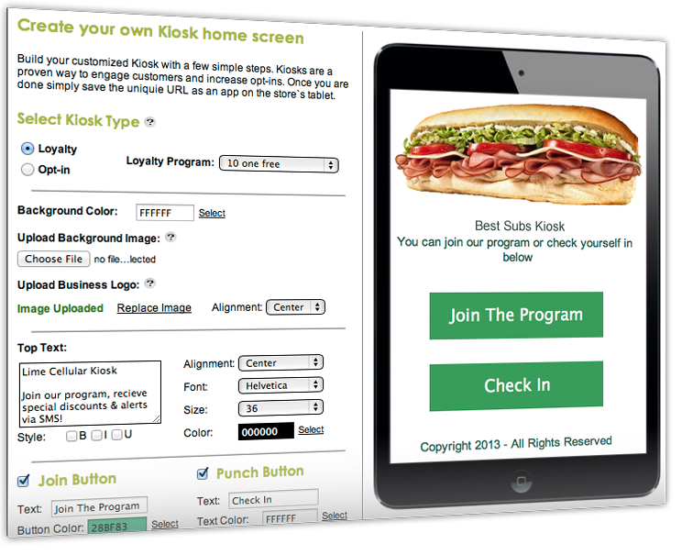

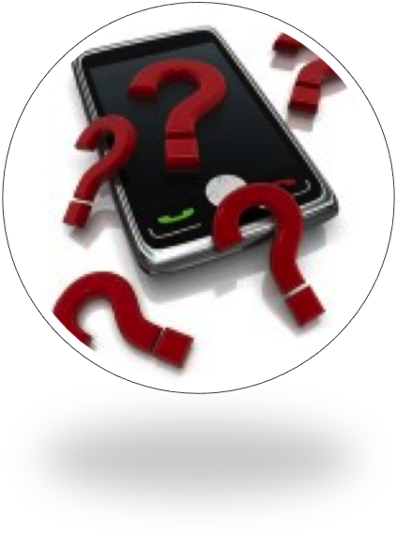

Run Your Own Campaigns Or We Can Do It All For You.

We offer a full service Mobile Marketing Platform designed to meet your needs to engage customers and get them to repeatedly use your services, attend your events, come to your restaurant during slow times, ect!

You can also leave all the marketing to us; We will take care of implementing and managing your messaging campaigns, your only duty is to take care of the increase in business coming your way!

__________’s platform delivers there features and more….

Loyalty Kiosk

Mobile Couponing

Mobile Surveys & research

Social Media Integration

Mobile Appointments & Conformations

Mobile Sales Alerts & Messaging

Learn more information about shows, events, ect

Multiple Keywords

Complete Reporting

Did You Know?
The average email marketing open rate is 26.17%, compared to 98% for SMS marketing. Why waste your money with ineffective strategies? Take matters into your own hands and give your clients/customers more reasons to use your business over and over again!

