
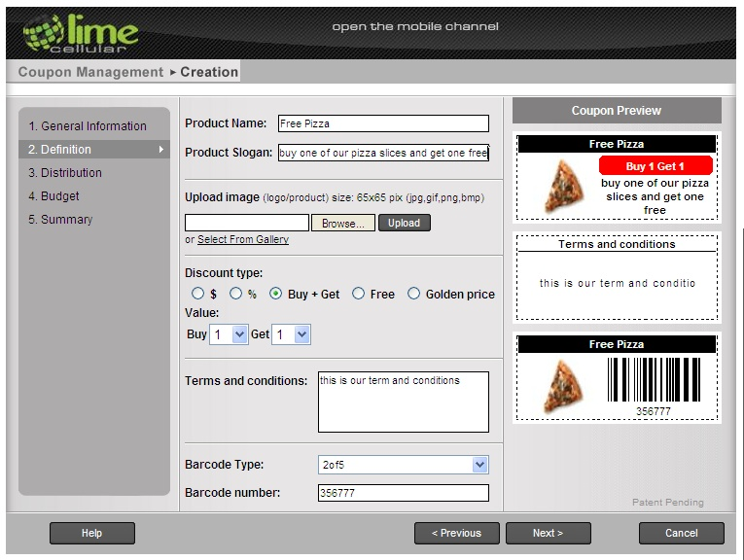
Mobile Marketing for Retail, Local Shops & More…
Mobile Marketing For Local Businesses…THAT WORKS!

For small & medium businesses: retailers, restaurants, associations and more. You can create your own mobile marketing campaigns with Lime’s self-service mobile platform.

Develop your own consumer lists, develop and launch targeted promotions, coupons, sales alerts and customer surveys & research! Our self-service platform is easy to use and you can launch your mobile program in minutes.

Recruit your customers to opt-in and begin delivering sales-driving promotions and store loyalty programs. You can stay in touch with your customers and drive increased traffic and sales by using ______.

Mobile Marketing For Local Businesses…On Demand!
Our platform was developed for the small and medium business market. ______ empowers the small and medium business community by bringing the power and sales-driving capabilities of mobile marketing to you cost-effectively and reliably – services usually reserved for only large organizations with big marketing budgets.

Now you can send the promotions and consumer communications programs you want, when you need them. ______’s platform is an “on demand” tool – use it according to your business needs, not according to media schedules or printing slots. And it’s designed to work on ANY cell phone.

______ puts you in charge of your customer relationships. You can manage your store loyalty programs, increase sales driving promotions, reward frequent customers.

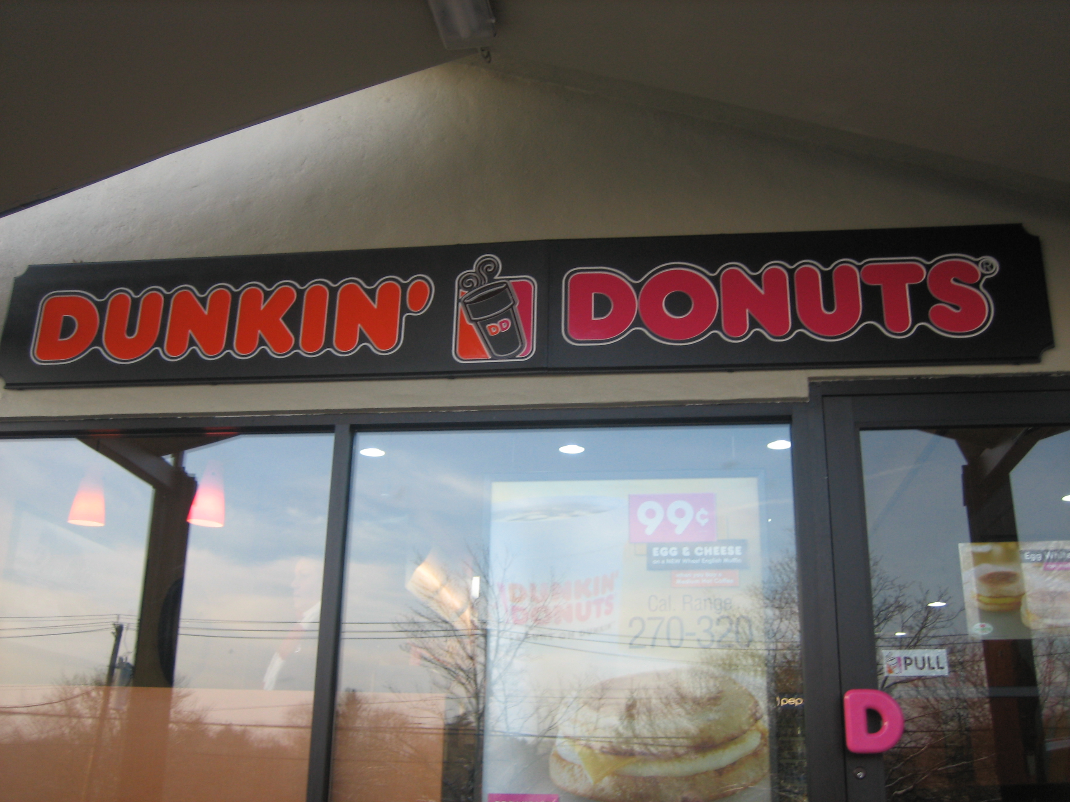

PLACE PHOTO HERE,
OTHERWISE DELETE BOX

“We’re able to move end- of-day inventory and reward loyal customers – at the same time.” -- TBGFAC – Dunkin’ Donuts, Regional Manager

Easy to start, Easy to manage…

- Open Your _____ Account & Create Offers & Promotions

Log into our easy-to-use dashboard and program launching platform and you’re ready to go.

- Recruit Consumers to Sign Up

Use in-store signage or install ____’s recruitment widget on your website.

- Send Your Customers Alerts, Promotions, Surveys and More

You can launch your programs immediately, or schedule them in advance.

- See Your Results – In “Real Time”

_____’s platform operates in “real time” – see your results as they happen – refine your programs “on the fly.”

Pricing starts at
$29.95 a month

- Full system access
- 1 unique keyword
- Start with 250 messages

After that, pay only for what you use. ____ offers a very competitive rate plan to keep your costs low and your customers engaged. Refer to our published rate card here.

The first account keyword is provided free as part of the monthly subscription. Additional keywords (up to a total of 10), are $49.95. After that, discounts are available.

Lime offers high volume and pre-paid pricing plans, as well. Contact us(PUT EMAIL LINK HERE) today for more information.
___________: For Local Businesses
We Offer A Complete “Turn Key” Mobile Service

_____’s platform delivers these features, and more…

- Customer Recruitment
- Mobile Couponing
- Mobile Surveys & Research
- Mobile Polling
- Mobile Appointment & Confirmation
- Mobile Sales Alerts & Messaging
- Learn more information about shows, events, etc
- Multiple Keywords
- Complete Reporting

Our development teams are adding new services and features all the time. We want our users to have the most up-to-date tools and services available.

Contact Us Today.
We can help get your store or shop started. Give us a call at the numbers indicated below.



PLACE PHOTO HERE,
OTHERWISE DELETE BOX

Any phone works with ______ -- you can reach out to ALL your guests and customers.
2010 ________. All Rights Reserved.
Open the Mobile Channel With _________ Today

Call: 800-699-9130

sales@site.com
www.site.com

Text "KEY" to 71441 for sales info.

